**Activity: Slag drier plant maintenance**

**Objective : -** Safe and quality maintenance of slag drier plant for optimum out put

**Scope : -** Blast Furnace Accessories

**Ref. : -** SDP drawing, other work instructions and procedures

**Responsibility : -** Engineer In charge & Maintenance Fitter on job

**PPE ?s to be used :** Helmet, Safety shoes, CO monitor, full body safety harness (double life line), hand gloves and goggle

Work No 1: For working inside slag drier kiln – (confined space entry)

Work no 2: Slag drier plant duct replacement

Work No.3: Belt structure replacement

Work No.4: Cyclone changing

Work No.5: Burner Changing or repair

Work No.6: ID fan impeller changing

Work No.7: Booster pump filter changing

Work No.8 Magnet Cylinder changing

Work No.9: Kiln shell replacement.

**Aspect- Impact**

|  |  |
| --- | --- |
| Scrap generation | Resource Depletion |
| Oil Spillage | Land contamination |
| Oil traced waste generation | Land contamination & Resource Depletion |
| Dust Generation | Air pollution |
| Fumes | Health |
| Fire | Air pollution SP-42 |

**Hazards identified**

**Physical Hazard** –

Temperature,

Fire,

Fall of oil in eyes, mouth, ear,

Inhalation of dust

**Mechanical Hazard** –

Trapping between two objects,

Fall of material, hammer, tools, slinged items, bolts, wedges from height

Fall of person from platform,

Tilting of crane / hydra due to uneven ground or load.

Impact of moving / slinged items

Trapping in moving rollers, gears, rollers, kiln moving parts, conveyor drives,

Fall of motor while dismantling / erection

Hitting of wheel loader or moving parts

Slip of person/equipment/material

Hitting purlins / sheet /equipments while handling with crane and hydra

Hitting of material while loading and marching

Entanglement between crane/hydra swing arm/counter weight

Hitting of crane hook

Entanglement of motor and screen between motor / screen and platform / other fixed members

Failure of D shackle, sling & crane

Burn injury during gas cutting and welding

Failure of crane rope and hook

Fall of material on crane cabin

Fall of object on person

Trapping of person in between screen and structure.

Back Pain due to sudden or heavy load like gear boxes, drums & motors

Slipping of saddle while taking load

Slipping of kiln while supported on saddle

Confined space entry inside kiln

**Electrical hazard** –

Electrical shock during welding

Electrical shock from lamps used

**Chemical Hazard** –

Gas poisoning,

Explosion due to gas cutting,

Unburnt gases due to improper firing & improper steam purging

**Human behavior**:

Operator nature, alcoholism, casual approach, back pain, horse play & non usage of PPE

**Work No 1: For working inside slag drier kiln**

*Working inside Kiln is a Confined Space activity*

*Confined Space Checks before job start up:*

1. *Before Entering in Confined Space ensure –*
2. *inside temperature should be less than 40 degree Celsius.*
3. *CO Level should be 0 ppm*
4. *Attendant must ensure proper illumination, if illumination not found ok, he must inform concern electrical person to provide hand lamp or halogen.*
5. *Take the work permit from production-in-charge, Safety, electrical, mechanical for entering Confined Space.*
6. *The workmen (Entrant) who is trained and certified by SBU Head and having valid confined space gate pass should perform the activity and he can be replaced(in emergency) only by certified entrant .*
7. *A standby (attendant) who is trained and certified by SBU Head and having valid confined space gate pass should perform the activity and he can be replaced(in emergency) only by certified attendant .*
8. *Standby person who shall be positioned outside the confined space , must have no other duties other than monitoring people and conditions inside the confined space and coordinating with rescue personnel (he must have contact number of rescue team members) if required.*
9. *Standby (Attendant) person has to log down the In/Out entry of all entrants and ensure that entrant should be come out after 30  minutes from confined space for normal jobs.*
10. *In some cases In/Out time may be relaxed /extended based on the risk involved in the particular confined space.*
11. *Check Internal atmosphere of the space for sufficient oxygen content (19.5% to 23.5 %) flammable gases and vapours, and the potential for toxic air contaminants by the use of multi gas detector, if required use pump with extension before entering. If there is any deviation, do not enter into confined space.*
12. *Check for the presence of Chemical asphyxiates such as Carbon monoxide (CO gas detector).It should be 0 PPM*
13. *Check inside temperature and it should be is in the tolerable range (25 deg C to 45 Deg C). If the temperature is not within limits then appropriate ventilation to be used to normalize the temp.*
14. *Check for suitability of equipment that is used at the confined space.*
15. *Check any dust due to which visibility is reduced or respiratory tract is irritated.*
16. *The sign-in and sign-out of all persons entering into confined Space should be recorded.*
17. *Use 24V DC supply illumination to avoid electrocution/electric shock.*
18. *Cutting or welding jobs inside the confined space should be carried out after checking for any explosive environment (LEL should be <10%) and by providing localized suction or heavy duty exhaust systems to prevent accumulation of gases inside the space.*
19. *Isolation of related equipment of respective confined space with personal LOTO lock to be Ensured.*

*Please note that this area is considered as Confined Space so needs to maintain the checklist of the activity. All In time and out time details of entrants, levels of gases to be logged in checklist (yellow copy) or in any alternate document and to be documented.*

***Role of Rescue Team***

***As the work is being carried out inside confined Space, in an emergency victim can be taken out by use of rescue apparatus such as stretcher. However attendant should call ambulance which is fully equipped. However rescue team members should take a charge of the situation.***

1. Obtain work permit from SDP control room/ furnace control room to take entry into kiln as it is a confined space.
2. Take electrical shutdown of kiln after positioning inspection door of kiln at bottom in manual mode.
3. Take electrical shutdown of vibrating screen as per shutdown procedure
4. Keep the ID fan running for 1 to 2 hours before entering the kiln so that heat inside is removed.
5. Gas line has to be water sealed by production department. Blank the gas line below expansion bellow as additional safety. The sealing rope has to fixed on the gas inlet side
6. Open inspection door of kiln and check for gas presence with CO detector. (CO detector to be carried inside kiln)
7. Ensure with the help of CO monitor there is no BF Gas inside and also the temperature is favorable to work.
8. Carry out the required maintenance activity
9. Remove all the material from the Kiln and ensure all the persons have come out of the kiln.
10. Inspect the kiln, burner and drifter plates.
11. Clear electrical shutdown and take trial in manual mode.
12. Hand over to production.

**Work no 2: Slag drier plant duct replacement**

1. Take work permit and confirm for water sealing of gas line.
2. Blank gas line near expansion bellow. Keep ID fan running for half hour to vent the trapped gas.
3. Make temporary platform/ proper scaffolding with hand railing wherever required for proper access while cutting the ducting.
4. Ducting should be slinged properly with tested sling at two points considering the centre of gravity.
5. Before starting the gas cutting of the duct, slightly load ducting with crane. Also tie a long manila rope to the ducting to avoid swinging.
6. Remove old ducting and align new ducting in position. Start welding the joints. Once welding work is completed, remove the load from crane.
7. All temporary platforms to be removed. Remove Gas line blank and give clearance to production
8. Refer WI/Maint/12 and SP44 for material handling, SP46 erection and dismantling.

9. Check for the leakages after starting of the plant.

**Work no.3 BELT STRUCTURE CHANGING**

1. Take electrical shut down of the belt and take work permit

2. Cut the belt at the joint and pull the belt backwards tying with manila rope.

2. Remove all cables (electrical and instrumentation dept) and pipe line from both the sides

3. Divide the belt structure into appropriate pieces so that it can be lifted easily with the crane

4. Provide support to the belt structure so that it don’t collapse on cutting

5. Dismantle the structure with the help of crane using proper tools and tackles.

6. Place the new pieces align it, bolt the structure and do the welding of joints.

7. Then remove the head end and tail end structures and place the newly made structure.

8. Conveyor belt to be laid on the structure and join it either by cold lagging/ hot lagging.

9. Place the side walk way grating and do the welding.

10. Simultaneously electrical can place the cables.

11. Clear the shutdown take trial for its alignment

12.Monitor the belt for smooth operation.

**Work No 4: CYCLONE CHANGING**

1. Take work permit and confirm for water sealing of gas line.
2. Blank gas line near expansion bellow. Keep ID fan running for half hour to vent the trapped gas.
3. .Make temporary platform for proper access while cutting the ducting.
4. .Ducting to be cut should be slinged properly with tested sling at two points considering the centre of gravity.
5. Before starting the gas cutting the duct, slightly load ducting with crane. Also tie a long enough manila rope to the ducting to avoid swinging.
6. Cut and remove old ducting
7. Remove the cyclone fully by using the crane and insert the new cyclone
8. Place new ducting in position. Start welding the joints. After welding is complete remove the load from crane.
9. All temporary platforms to be removed. Remove Gas line blank and give clearance to production
10. Refer WI/Maint/12 and SP44 for material handling, SP46 erection and dismantling.

**WORK NO.5 BURNER CHANGING OR REPAIR**

1. Take work permit and confirm for water sealing of gas line.

2. Blank gas line near expansion bellow. Keep ID fan running for half hour to vent the trapped gas

3. Remove the oil gun and all instrumentation equipments

4. Remove the pipe to be changed with the help of hydra or any suitable vehicles.

5. Place the new fabricated part and align it with the center of the kiln. Clearance variation should not be more than 30mm.

6. Weld the duct after completion of the alignment completed with 7018 welding electrode.

7. Do the castable work wherever required.

8. Fix the burner flange and tighten the bolts equally.

9. Fix all the oil guns, hose and ducting.

10. Take trial after completion of all other job and check for the leakage.

**WORK NO.6: ID FAN IMPELLER CHANGING**

1. Run the ID for half an hour to remove all the residual gases after plant is stopped
2. Take production clearance and electrical shut down of the ID fan.
3. Remove all the inspection covers of the casing duct and check for CO presence using CO monitor
4. Remove the V belts from the pulley by loosening the motor base bolts. (Trapping hazard in groove)
5. Loosen the mounting bolts of the Plummer block slightly. The Plummer block in the coupling side should be removed after slinging only ( to avoid unbalance of overhung impeller assembly)
6. Remove the casing cover, suction cone and impeller. Remove the Plummer block bolts while lifting the impeller.
7. Place the new assembly along suction cone and fix the Plummer block bolts..
8. Place the casing cove and tighten the bolts of casing and suction cone.
9. Aligned the Impeller and suction cone by slightly loosening the suction cone bolts.
10. Check the bearing for tightness and lubricate it.
11. Align the motor and fan properly and fix the V belts of correct size.
12. Clear the shutdown and take trial.
13. Check the direction of the impeller and take vibration readings.
14. Do not remove the bolts of coupling side Plummer bloc / foundation bolt as the fan assembly can suddenly get lifted. Ensure proper supporting before loosening these bolts ( overhang design of fan)

.Note: NEVER REMOVE THE PLUMMER BLOCK COVER AT THE NON DRIVE END WITHOUT PLACING PACKING BELOW THE IMPELLER VANES.

**WORK NO.7 BOOSTER PUMP FILTER CLEANING**

1. Take production clearance.

2. Close discharge valve of both the pumps.

3. Close the suction and discharge valves of the filter so as to isolate it.

4. Open the drain valve at the side to drain water.

5. Remove the top cover of the filter (30-32 RD spanner).

6. Remove the inside holding plate of the filter (18-19 RD spanner)

7. Remove the filter and clean with fresh water.

8. Place back the filter, holding plate and the cover.

9. Open all discharge valve of pumps and suction and discharge valve of the filter

10. Run pump with air release valve open till water comes out of the valve.

**WORK NO.7 OIL GUN CLEANING**

1. Take production clearance

2. Remove the diesel and air line hoses from the back side of the gun

3. Remove the bolt at the back of the gun to release the gun.

4. Remove the nozzle at the front of the gun and clean the nozzle thoroughly.

5. Place the gun back after fitting the nozzle tighten the bolt holding the gun.

6. Fit back the air and diesel line hoses and make sure no leakage is present.

**WORK NO.8 MAGNET CYLINDER REPLACING**

1. Take clearance from production

2. Position the magnet near the hand railing of the bridge to slag shed

3. Close the pneumatic valve of the line and make sure the cylinder is not operating.

4. Remove the hose pipes of both ends slowly and keep the hoses end tied with clean cloth so that no dust will go inside.

5. Remove the bolts holding the cylinder at the back side.

6. Remove the bolts holding cylinder piston and magnet wheel.

7. Place the clamps at one side and slightly lower the cylinder.

8. Replace the cylinder and put back the bolts.

9. Adjust the clamps such that cylinder is in balanced position and connect the hoses.

10. Open the valves and take trial.

**WORK NO.9 KILN REPLACEMENT**

**Pre shutdown jobs**

1. Dismantling of roof sheets, purlins and shed columns to be carried out 1 day prior to final shutdown. Purlins and columns have to be dismantled using hydra.

2. Water pipeline fouling while carrying out the job should be isolated and dismantled.

3. The land needs to be leveled as per requirement one day before commencement of the job by 50/100T crane. All fabricated items and material should be removed and free access to be made to place the kiln. Few branches of trees also may be required to be cut to make free access.

4. 5 nos of saddles to be kept ready fabricated as per sketch-1, prefabricated hooks 8 nos.

5 Jacks of 50 and 100T to be kept ready which have valid test certificate.

6. On the day of shutdown overhead HT cables need to be removed to make access for 50T crane to shift the kiln shell to site.

The kiln shell to be shifted one by one from sizer plant to slag dryer area. The kiln will be loaded in a trailer/truck of adequate size. The road of travel should be barricaded and flagged. The kiln will be loaded and unloaded using 50/100T crane.

1. After plant shut down is taken run the kiln in order to empty dry slag

2. After slag is emptied water seal the gas line and then steam purge the kiln. Put a blank in the gas line for additional safety.

3. Take cold alignment readings and take shut down of the kiln, belts and vibrating screen

Remove the V belts of drive (as per procedure of V belt changing), decouple the gearbox and remove motor, gearbox and pinion using hydra or crane

4. Run the ID for 30 min in order to remove any residual gas trapped inside kiln

5. Dismantle the portion of platform above kiln sealing arrangement.

6. Remove the kiln labyrinth seal (kiln sealing arrangement). Also remove the discharge end side box using crane.6.

Please refer sketch-1 for dismantling of kiln.

7. Make all round cut of about 400 mm so that the shell is free from the feed box end. This 400mm portion has to be removed in 5 to 6 pieces.

8. Fix pre-fabricated clamps on top of kiln shell for dismantling of shell by crane. Each piece of shell being dismantled should have 2 clamps to take the load. Use minimum 5 T tested metallic sling for the job. 50T crane for dismantling job.

9. First portion of the kiln to be removed will be from cold end side sealing arrangement till just before the cold end tyre (say cut to be made 250mm before cold end tyre on feed side).

10. Now to remove the second portion, following preparation has to be made. Provide saddle support to the kiln at 3 places. 1st after cold end tyre, 2nd just before girth gear and 3rd after hot end tyre (discharge side).

11. Now 2nd portion to be removed is the cold end tyre along with portion of the shell. Cut should be made at a distance of 300mm from tyre on hot end side.

12. Now the kiln will be supported on one tyre and 3 saddles.

13. To remove the 3rd piece of kiln shell weld 2 pre fabricated hooks on top of shell. Make a cut before the girth gear (also before the saddle). Remove it using crane.

14. In the 4th piece girth gear along with portion of the shell has to be removed. Make a cut in between the hot end tyre and girth gear. Remove the girth gear using crane.

15. Now to remove the 5th piece another saddle has to be fixed at the hot end side after the tyre. The 5th piece to be removed will be the hot end tyre along with some portion of the kiln shell. Remove 5th portion using crane.

16. Now the last portion to be is the 6th portion. This portion will be only supported on 2 saddles. Fix pre fabricated hooks and remove using crane.

**Preparation for erection of new kiln shell**

**Fixing of tyre and gear on cold end shell**

1. The cold end tyre and gear to be removed from the bolts by keeping tyre and gear on the ground. Hydra or crane to be used in case assembly is required to be turned to carry out the job.

2. Please refer sketch-2 for pre erection jobs of kiln shell.

Fix pre-fabricated clamps on the shell at 2 mts distance from both the ends of the shell

3. New cold end shell to placed over 3 saddles placed at equal distance.

4. Slide the gear on the shell using crane. .

5. When the gear reaches the first saddle fix a saddle at the end of the shell from which sliding started. Remove the saddle which is obstructing the gear movement. Saddle removal and fixing to be done by lifting the kiln shell using 50T crane. The shell lifting hook is also required to be cut and relocated to make way for gear and similarly for tyre.

6. Similarly saddle need to re adjusted till gear reaches its position as per Drg No. PIP-1-1229 Rev.B

7. Similarly cold end tyre also need to be fixed loose on the shell

8. After positioning both tyre and gear need to be locked by welding rods to it with the shell.

9. Fix the wedges for the tyre and gear. Final welding of the same to done according to the cold alignment reading.

**Erection of Shell**

1. Fix saddle for every 4 meters along kiln axis (total 4 nos).

2. Adjust the saddles by providing proper packing below such that after placing the shell on saddle there is minimum 100 mm gap between guide roller and tyre. This has to be done before erection is done.2.Lift the cold end shell along with tyre and gear and place over the saddle placed along with kiln axis.

3. Lift the hot end shell and place over the saddle s fixed along the kiln axis

4...While lifting it has to be ensured that the arrow mark made on the flange for fixing of bolts to be on the same side.

**Fixing of tyre on hot end shell**

1. Slide the hot end tyre from the discharge end of the kiln using crane

2. When the tyre reaches the first saddle from the discharge end, lift the shell using the crane and remove the saddle.

3. Again rest the shell on the saddle and slide the tyre to the required position as per Drg No.PIP-1-1229 Rev B.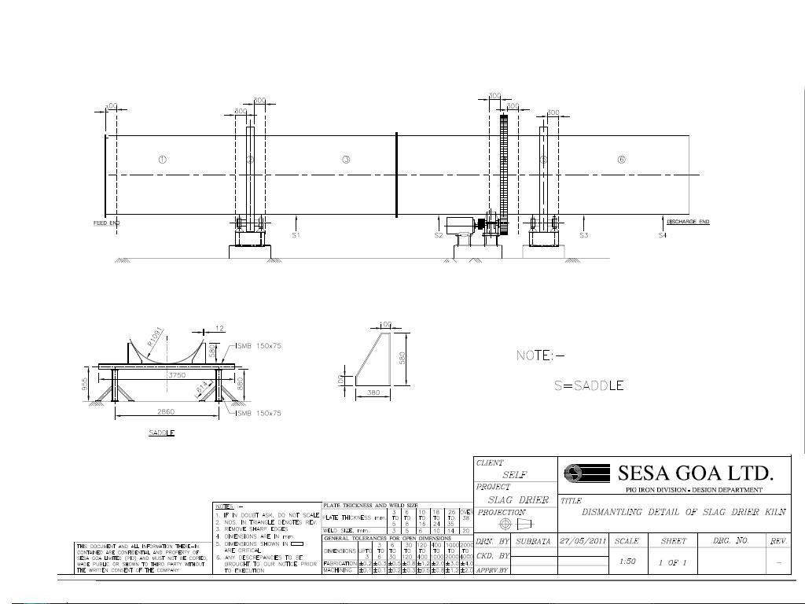

4. Fix the chair pads by inserting freely.

5. Shim adjustment to be done according to the cold alignment reading

**Joining the shell and final jobs and trials**

1..Keep cold end shell stationary and slightly move hot end shell using crane and bolt the flange joint between two shell pieces.

2. Raise the hot end using jack and remove the saddle. Lower the side using jack

3. Repeat the same for the cold end.

4. As per cold alignment readings the guide rollers to be adjusted. Mount pinion, gear box and motor on base frame using crane. Take decouple trials. Couple the drives. Put back all the safety guards/coupling guards and take trials simultaneously fix thrust rollers.

5. on running condition guide rollers to be adjusted.

6. Sealing plates to be welded on the shell at the cold end side and seal cover to be fixed after alignment job is completed. Also adjust thrust roller as per shell position. Drifter plates need to be fixed inside shell.

7...Discharge chute cover to be fixed back and material to be loaded (after clearing the belt shut downs) in the kiln.

8. Kiln to be rotated in actual running conditions and alignment to checked and set.

9. Platform which was cut for removal of shell at the inlet of shell to be fixed back.

DOS

1. Use safety belt / harness while working at height
2. No one should stand close to slinged item, below the slinged item
3. Cordon the area below working
4. Level the ground if required for proper positioning of crane.
5. Use tested slings, D shackles and certified crane
6. 6.Use PPE,s for working
7. Use dust mask compulsorily for working inside kiln
8. Use CO monitor while going inside kiln. And ducts.

DONTS

1. Remove drive end Plummer block cover of SDP ID fan.

2. Work at height without wearing safety belt.

3. Allow workmen to work if he is found drunk.

4. Allow welding cables whose leg is not proper.

5. Work inside kiln without dust mask, goggle and CO monitor.

6. Weld on kiln without giving direct earthing.

**Amendement Record**

|  |  |  |  |
| --- | --- | --- | --- |
| **Date** | **Manual Section Ref. & Para** | **Brief details of Revision** | **New Rev.** |
|  |  |  |  |
|  |  |  |  |
|  |  |  |  |

|  |  |  |
| --- | --- | --- |
| **Prepared By:**  Area Engineer | **Reviewed & Issued By:**  Management Representative | **Approved By:**  Mechanical Head |
| **Signature** | **Signature:** | **Signature:** |
| **Review Date: 12.12.22** | **Review Date: 12.12.22** | **Review Date: 12.12.22** |